1. Launch Amazon Web services through Quantiphi gmail
2. Select North Virginia (Client Location) as the location

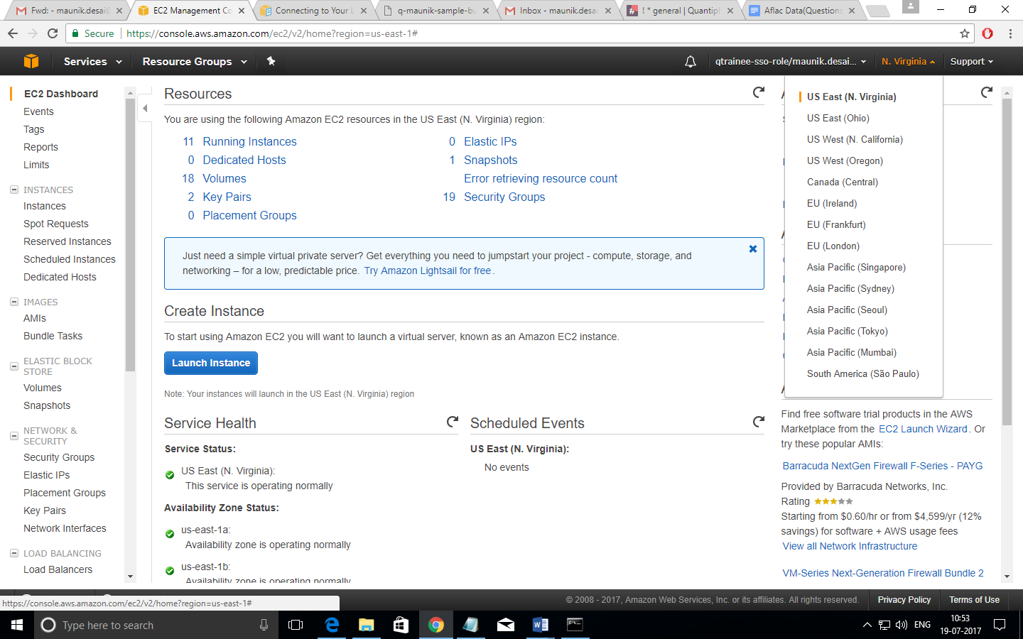

1. Under ‘All Services/Compute’ click EC2
2. Click Launch Instance

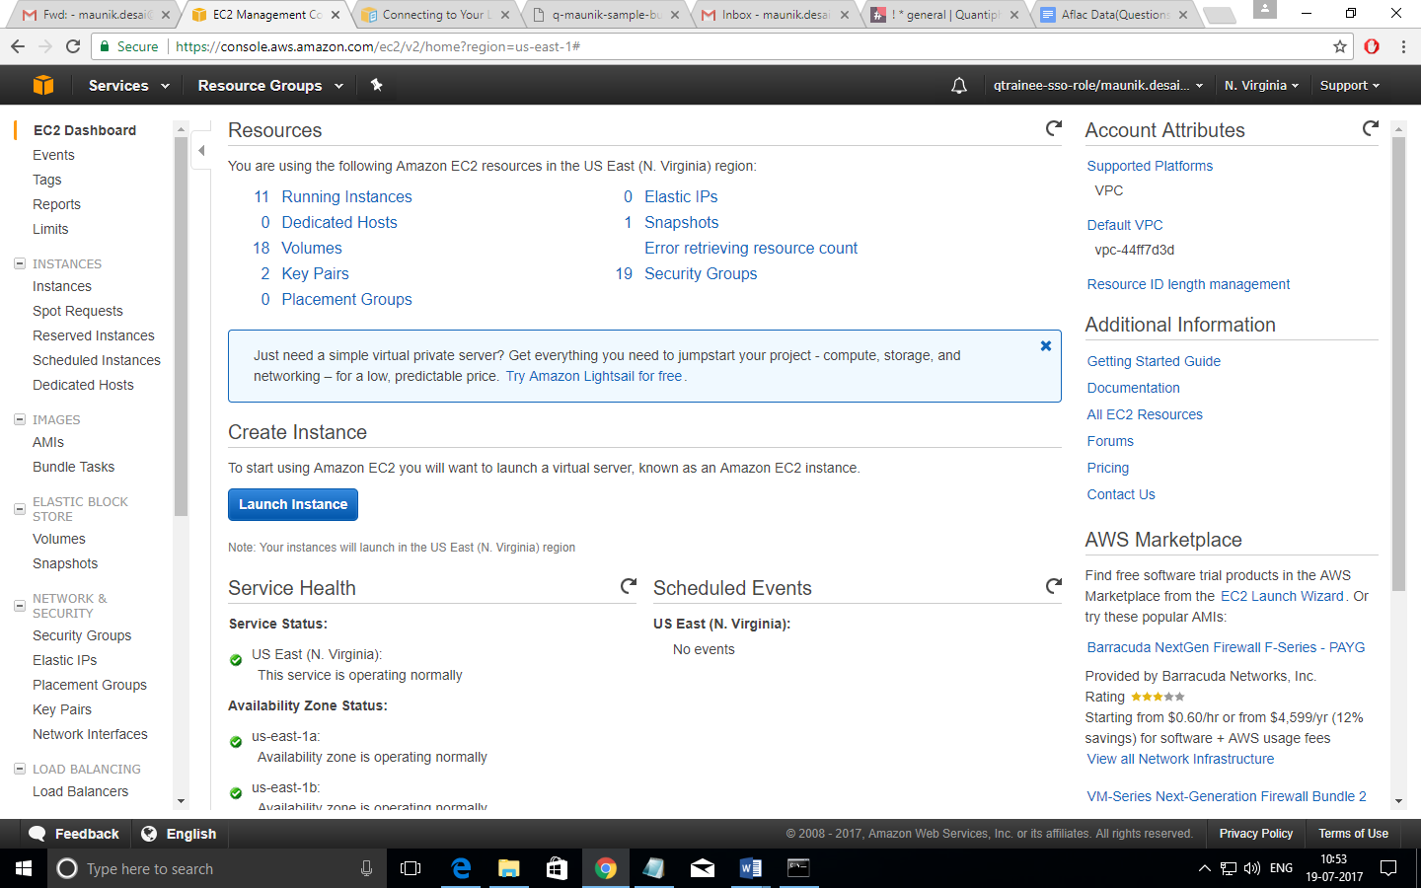

1. Choose an Amazon Machine Image (AMI), click Amazon Linux AMI 2007-64 bit

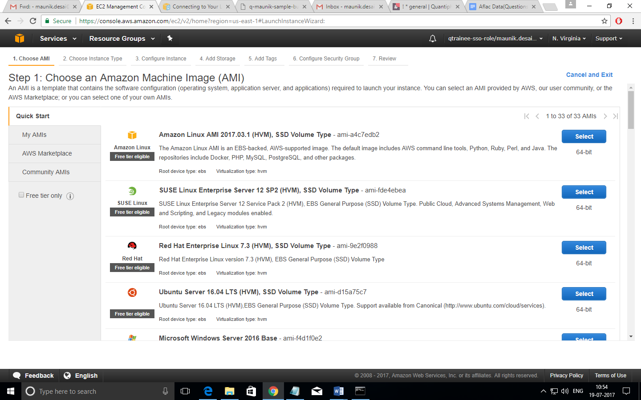

1. Choose an instance type, select t2.micro in the General Purpose Family

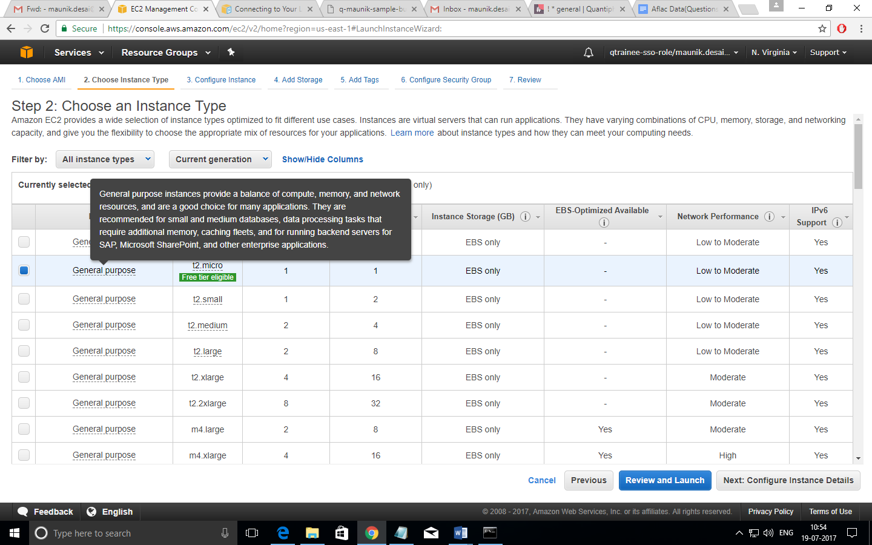

1. Click Next: Configure Instance Details
2. Change Settings as needed and click Next: Add Storage

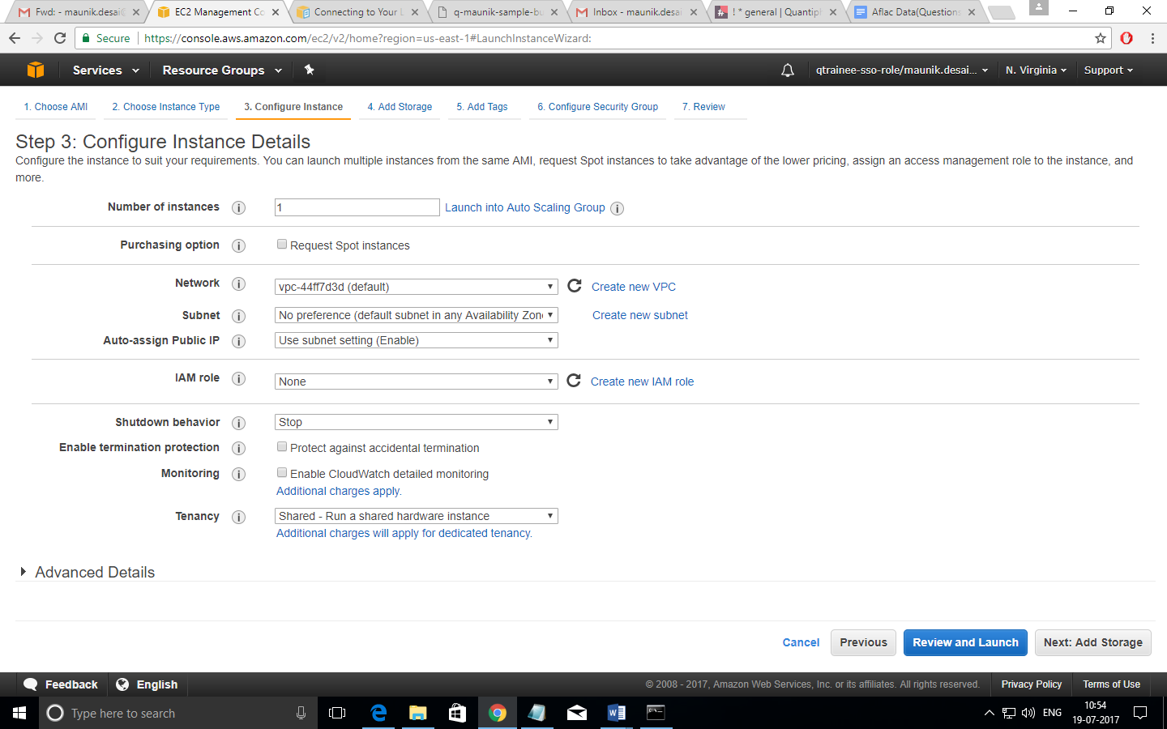

1. Choose Size, and volume type, click Next: Add Tags

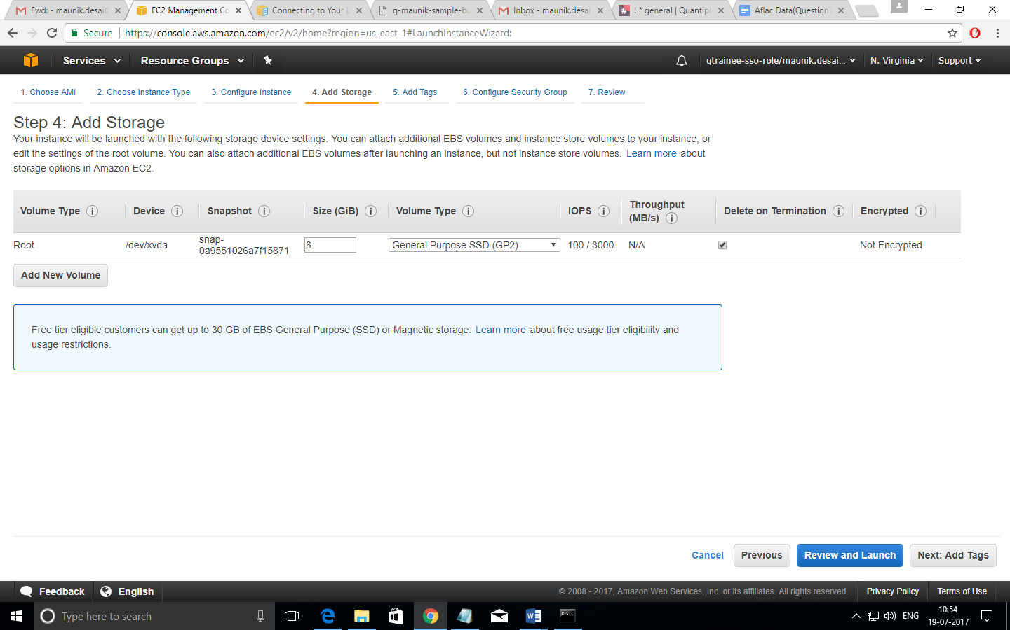

1. Add the key-value pair of tags and click Next: Configure Security Group

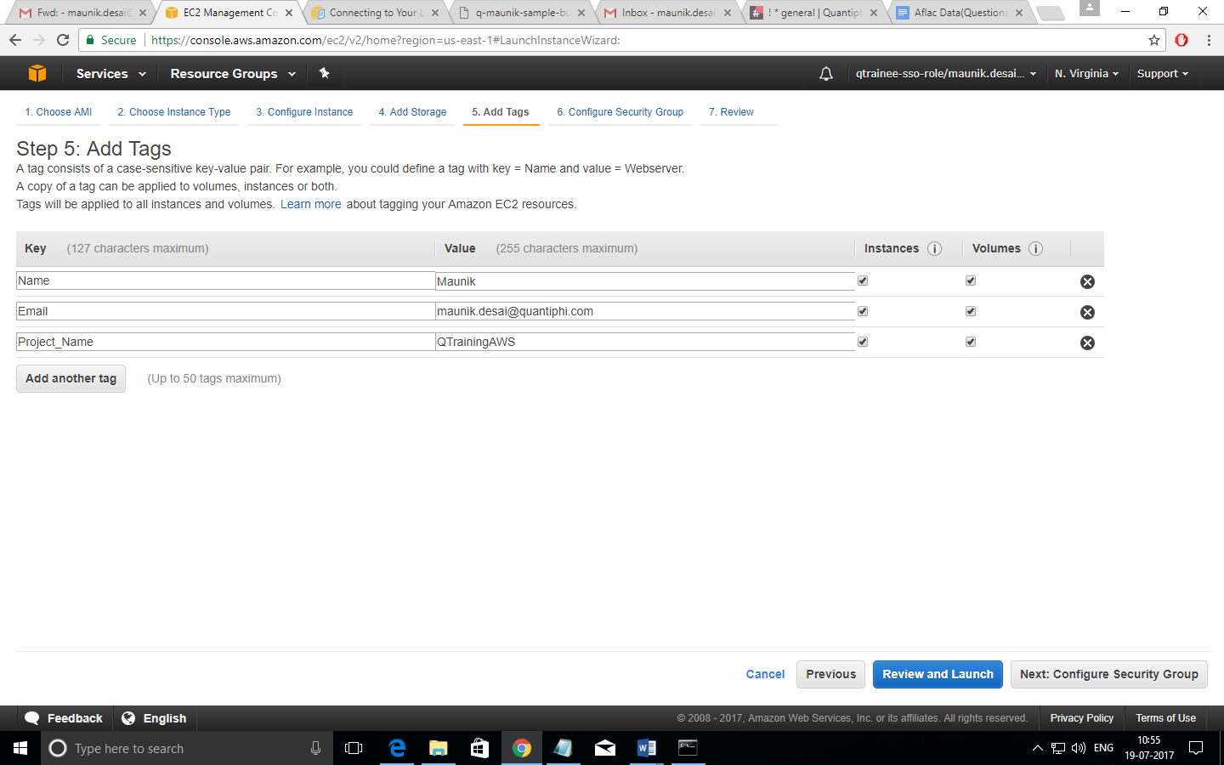

1. Select the type of protocol and choose source according to its utility, prefer MyIP

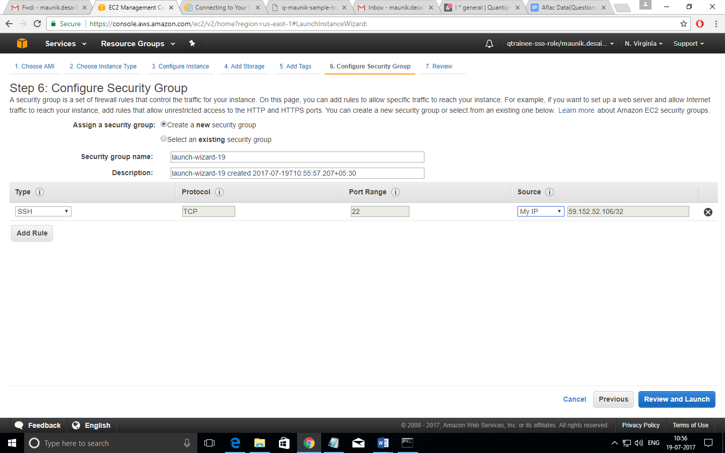

1. Select an existing security group

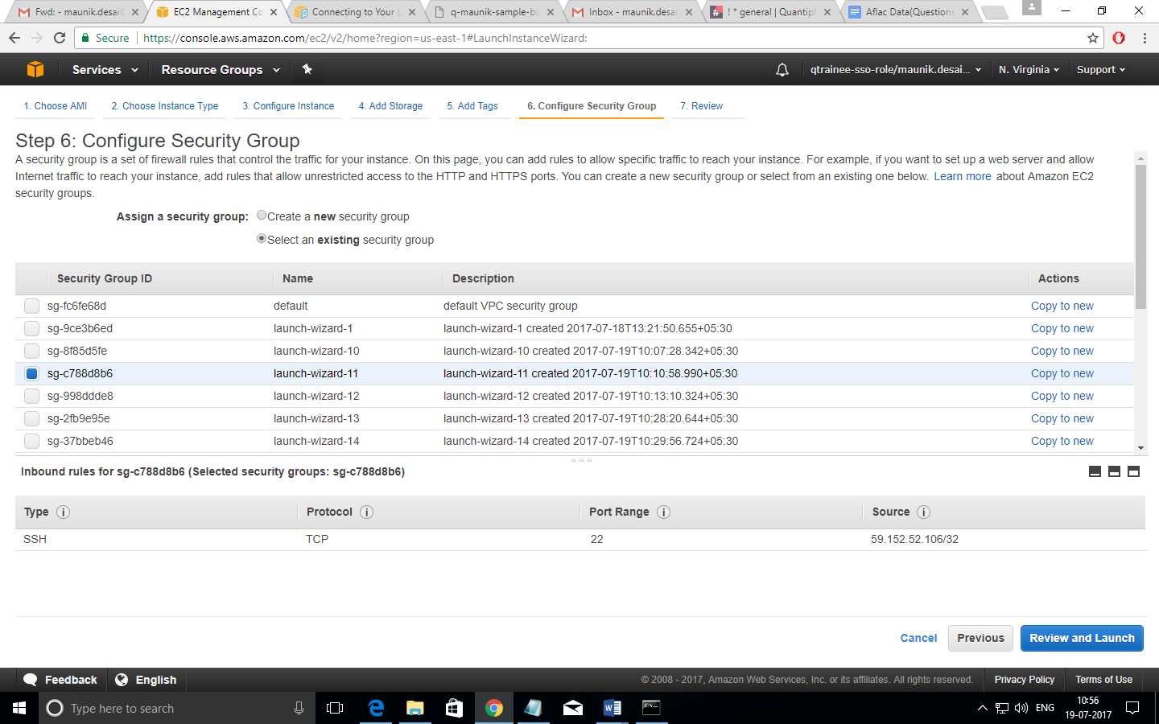

1. Review your selections and click Launch

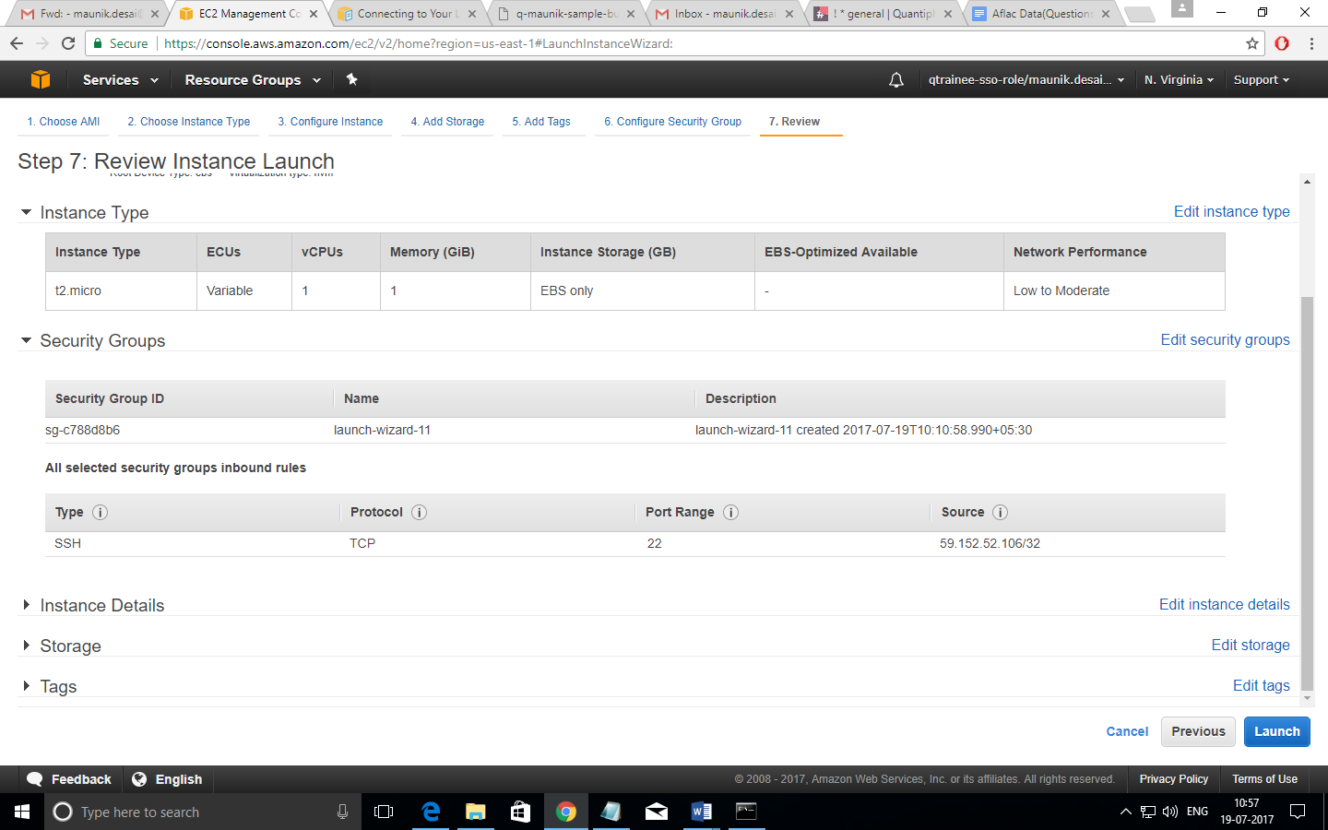

1. Select either an existing key pair or create a new key and click Launch Instance

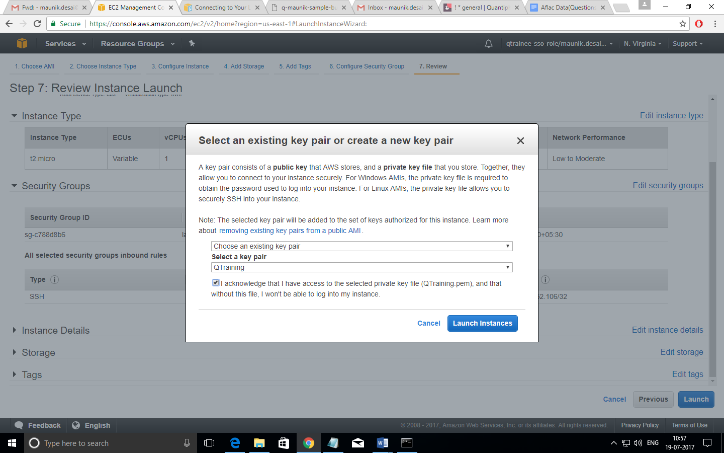

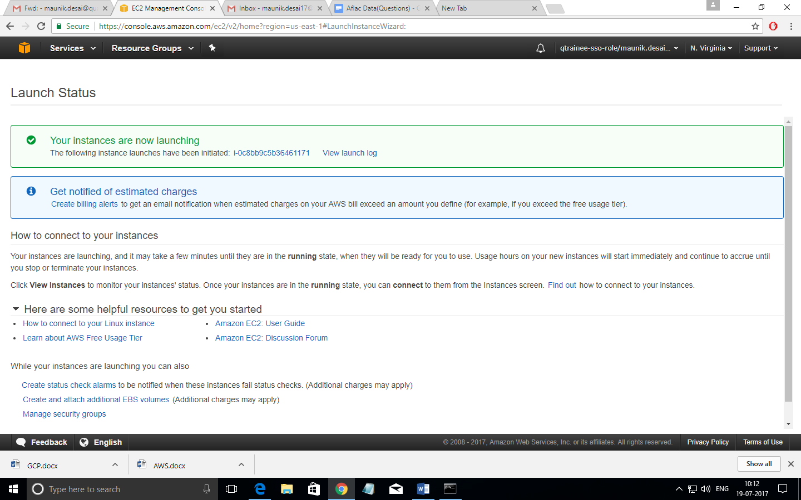

1. The instance is being initiated

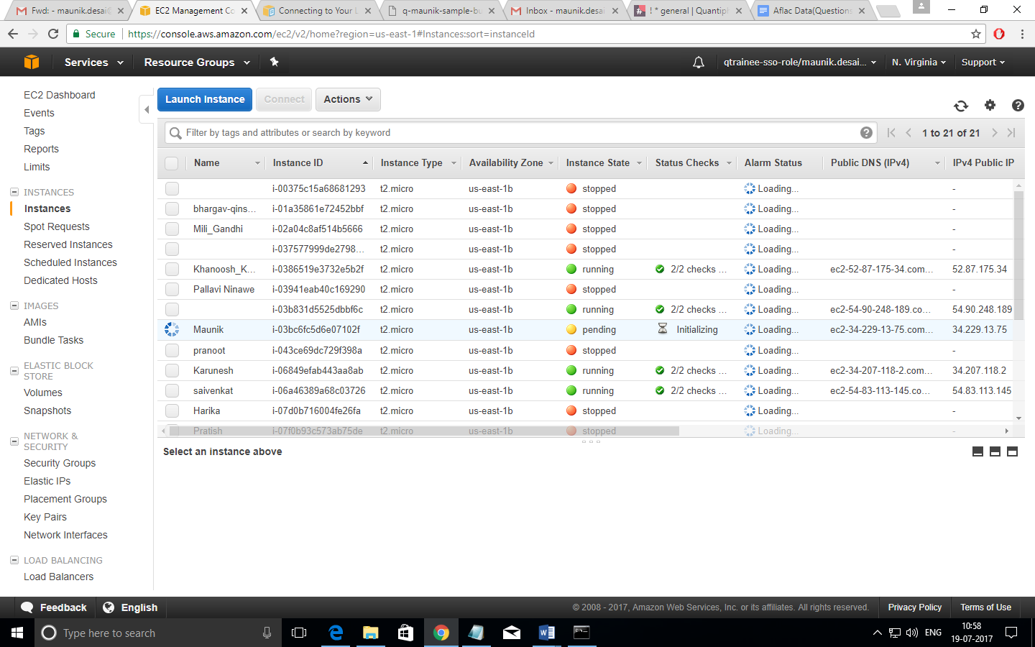

1. To terminate your instance, click your instance name, select actions, under actions select Instance State Terminate to stop your instance